1. Right Click .html file and open with Internet Explorer or Google Chrome or Firefox

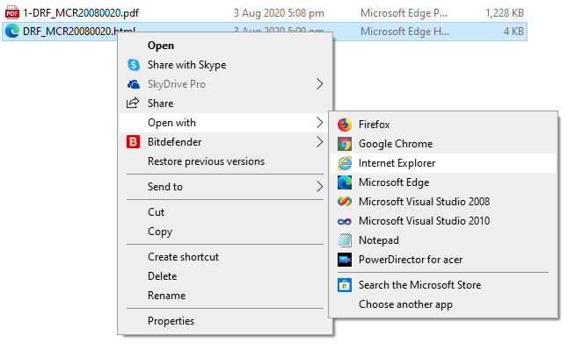

1. The .html is file look like below image (This example is open in Internet Explorer) If you see pop-up blocker “**Allow blockedcontent**” just click it or allow it. This is usually appear in IE and not in other browser like Chrome.

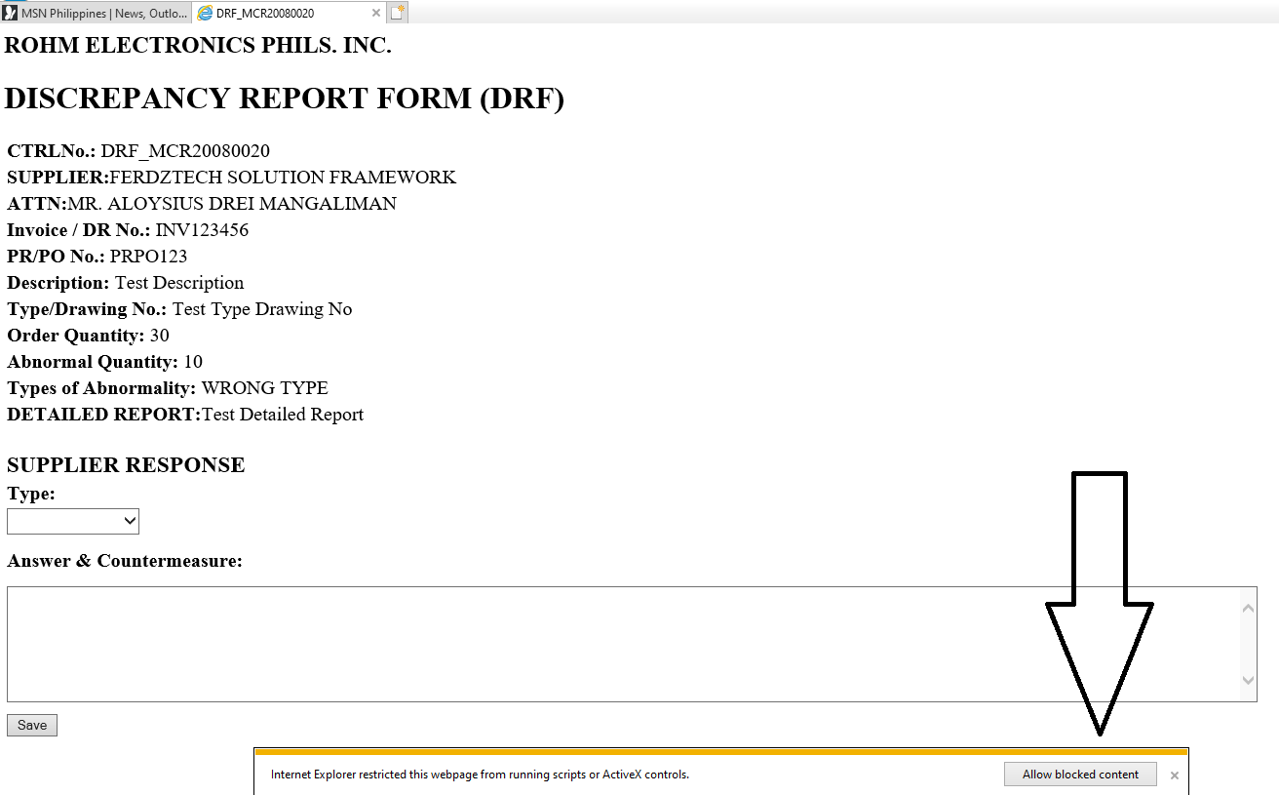

1. In SUPPLIER RESPONSE, select **type** and put your answer in **Answer & Countermeasure** field then CLICK **SAVE.** Below Save button you will see the confirmation box saying “Do you want to save **CSVFile** from YourComputerName”. Just CLICK**SAVE**then that should be good.

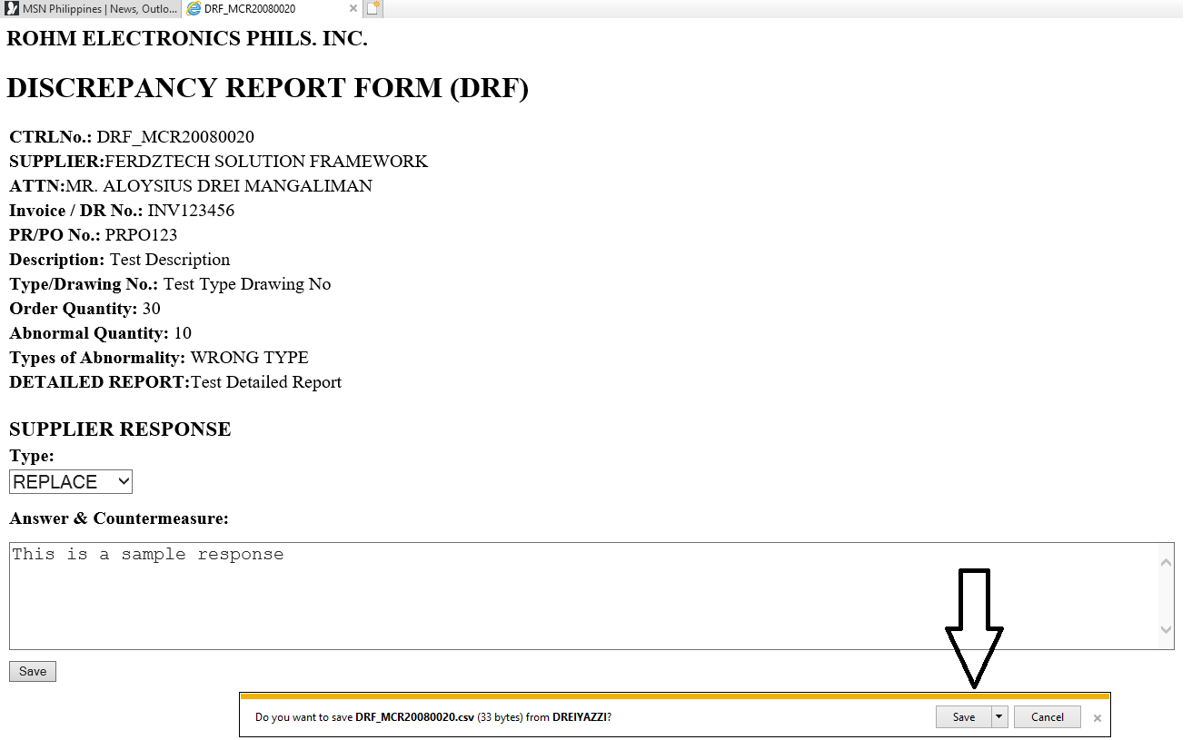

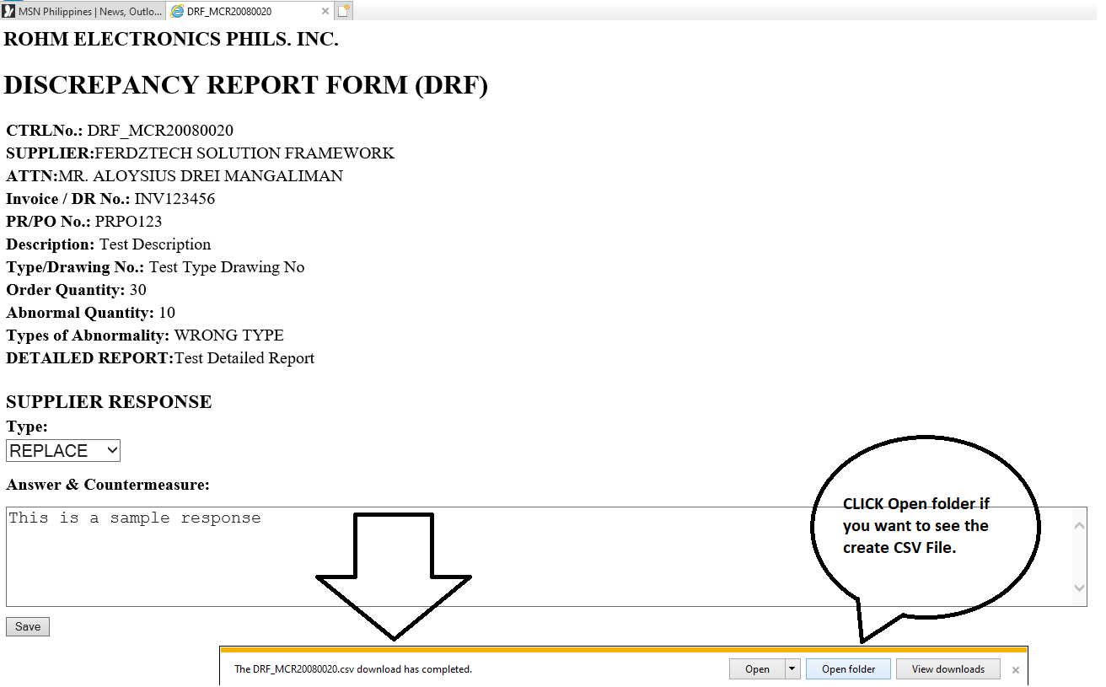

After clicking Save, you will be able to see “The DRF_File.csv download has completed. If you want to see the created CSV File just click the Open Folder and should find it. The file usually save in the Download folder by default.

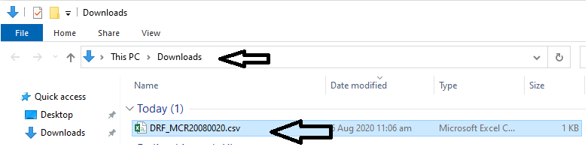

1. After that you can now attached that csv file to the original DRF Email Request that you received. Do not add any message because buyer will not able to read your message because the system will only get whatever you put in the Answer & Countermeasure field and Type which is in the attached CSV File. **PLEASE MAKE SURE THAT YOU ATTACHED THE CORRECT & VALID CSV FILE (DRF_MCR20080020.csv (1) is NOT VALID, DRF_MCR20080020.csv is VALID)**

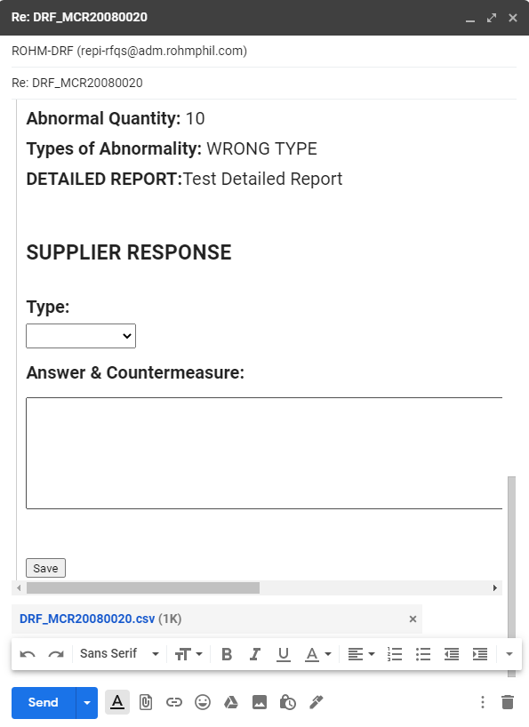

Lastly, click **SEND**

**THANK YOU!**